TECHNICAL STANDARD | ST-IGG-4401:2022
Methods for determining methane emissions from the gas network

PREFACE
According to the draft Regulation (EU) of the European Parliament and of the Council on the reduction of methane emissions in the energy sector and amending Regulation (EU) 2019/942, the natural gas extraction sector, as well as transmission and distribution network operators, will be required to monitor and report methane emissions by emission source and to conduct Leak Detection and Repair (LDAR) programmes. From the date of entry into force of the above-mentioned legal act, the gas sector will have only 3 years to adapt to the new reporting requirements and less than half a year to implement the LDAR system.
The standard presents the methods for determining the amount of methane emissions at gas facilities, taking into account both the current and the proposed legal acts. The standard takes into account the requirements contained in:
- Act of 27 April 2001. Environmental law,
- Act of 17 July 2009 on the system for managing emissions of greenhouse gases and other substances,
- proposal for a Regulation (EU) of the European Parliament and of the Council on the reduction of methane emissions in the energy sector and amending Regulation (EU) 2019/942.
The standard also describes good practices from initiatives such as the IPCC and the OGMP.
The standard contains eight annexes:
- Annex A (informational): Examples of leaks in the gas transmission network
- Annex B (informational): Examples of leakage locations for gas distribution networks
- Appendix C (Informational): Overview of Leak Detection Methods
- Annex D (informational): Overview of methods used to measure methane emissions
- Appendix E (informational): Tabulated gas outflow rates from low- and medium-pressure pipelines through a well-known surface area for gas pipelines
- Annex F (informational): Geometric volumes of gas pipelines with a length of 1 km
- Annex G (informational): Emission source categories for OGMP levels for the transmission and distribution of natural gas
- Appendix H (informative): Bibliography
It is recommended that this technical standard be introduced for use by companies associated in the Gas Chamber of Commerce in order to start the process of adapting the gas industry to the new reporting obligations on methane emissions resulting from the adopted EU strategy for reducing methane emissions.
Established by the President of the Management Board of the Gas Industry Chamber of Commerce on the basis of a resolution
No. xx/2022 of xx mmmmm 2022 Board of the Chamber of Commerce of the Gas Industry in Warsaw
© No part of this Technical Standard may be reprinted or copied by any technique without the written consent of the President of the Board of the Gas Chamber of Commerce
TABLE OF CONTENTS
1 Scope 3
2 Standards and documents cited 3
3 Terms and definitions 3
4 Sources of methane emissions in the gas industry 5
4.1 Natural Gas Transmission 5
4.2 Natural Gas Distribution 6
5 Recommended methods for the detection and measurement of volatile methane emissions 7
6 Determination of methane emissions 7
6.1 Methods for determining volatile emissions based on emission factors (EF) and activity factors (AF) 8
6.2 Correlation Method for Estimating Volatile Methane Emissions 11
6.3 Balance methods for determining emissions related to technological leaks and failures 11
6.4 Calculation methods for the determination of emissions related to technological leaks and failures 11
7 Methane Emissions Inventory 14
7.1 OGMP 14
7.2 IPCC 14
Appendix A 16
Appendix B 18
Appendix C 22
Appendix D 25
Appendix E 28
Appendix F 29
Appendix G 30
Appendix H 32

1 Scope
The scope of the standard includes recommendations for reporting methane emissions from the transmission and distribution of natural gas.
The standard indicates the places where methane leaks occur most often. Methods for detecting and measuring emissions were reviewed.
The standard also presents calculation and coefficient methods for determining the amount of methane emissions from the gas network.
Due to the proposed legal acts in the field of methane emissions, this standard should be used only to the extent not regulated by national and EU legislation.

2 Standards and documents cited
In order to apply this Standardization Document, the following documents are necessary, which in whole or in part have been normatively referred to therein. In the case of dated citations, only the cited edition applies. In the case of undated appointments, the most recent edition of the document invoked (including amendments) shall apply.
PN-EN 15446 Uncontrolled and diffuse emissions in the industrial sector – measurement of vapour emissions from leaking installations and pipes
IPCC Guidelines for National Greenhouse Gas Inventories 2006
Communication from the Commission to the European Parliament, the Council, the European Economic and Social Committee and the Committee of the Regions on an EU strategy to reduce methane emissions of 14.10.2020
Marcogaz "Assessment of methane emissions for gas Transmission and Distribution system operators"
Mineral Methane Initiative OGMP 2.0 Framework
U.S. Environmental Protection Agency (US EPA) & Gas Research Institute (GRI) "Methane emisssions from the natural gas industry"
Regulation of the Minister of Economy of 26 April 2013 on the technical conditions to be met by gas networks and their location
Regulation of the Minister of Climate of 11 December 2019 on lists containing information and data on the scope of use of the environment and the amount of fees due
Regulation of the Minister of the Environment of 14 November 2016 on the detailed scope of information contained in the report and the method of its entry into the National Database on Emissions of Greenhouse Gases and Other Substances
Law of 27 April 2001 Environmental law
Act of 17 July 2009 on the Management System for Greenhouse Gas and Other Substances Emissions

3 Terms and definitions
For the purposes of this Standardization Document, the terms and definitions listed below shall apply. Technical terms used in this Standard, not defined in the following chapter, should be understood in accordance with Article 2 of the Regulation of the Minister of Economy of 26 April 2013 on technical conditions to be met by gas networks and their location.
3.1 Malfunction
an unplanned event resulting in methane emissions, most often caused by system malfunctions resulting from the actions of third parties and/or external factors
[SOURCE: Marcogaz - Assessment of methane emissions for gas Transmission and Distribution system operators]

3.2 Issuance
the introduction of substances directly or indirectly, as a result of human activity, into air, water, soil or land
[SOURCE: Environmental Protection Law of 27 April 2001]
3.3 Volatile emissions
emission to air, caused by the loss of tightness of the element that was designed to be tight
[SOURCE: PN-EN-15446:2008]
3.4 Emissions from incomplete combustion
unburned methane in flue gas from gas turbines, gas engines and combustion plants and flares
[SOURCE: Marcogaz – Assessment of methane emissions for gas Transmission and Distribution system operators]
3.5 Incident
Event not classified as a failure
[SOURCE: PSG Event and Crash Handler]
3.6 Installation
Installations are understood as:
- stationary technical equipment,
- a set of stationary technologically related technical equipment, the legal title to which is held by the same entity and located on the premises of one plant,
- structures that are not technical installations or assemblies thereof,
the operation of which may result in emissions.
[SOURCE: Environmental Protection Law of 27 April 2001]
3.7 Place of use of the environment
are areas (locations) where the entity conducted activities resulting in the emission of pollutants into the air in a given reporting year
[SOURCE: National Centre for Emissions Management https://krajowabaza.kobize.pl]
3.8 Permeation
permeation of permeate (such as liquid, gas, or vapour) through a solid. In the case of natural gas transported through polyethylene pipelines, this phenomenon is directly related to the gas pressure and the self-permeability of polyethylene.
[SOURCE: Marcogaz – Assessment of methane emissions for gas Transmission and Distribution system operators]
3.9 Pneumatic device
Equipment such as chemical injection pumps, compressor unit drive starters, instrument control loops, liquid level gauges, pressure regulators, valve controllers, using pressurized natural gas or compressed air as the feed medium.
[SOURCE: 2019 refinment to the 2006 IPCC Guidelines for National Greenhouse Gas Inventories, Chapter 4]
3.10 Activity Factor (AF)
A numerical value describing the size of the population of methane-emitting devices, e.g. length of gas pipelines, number of valves (by type), number of pneumatic devices (by type), or frequency of emission events
[SOURCE: Marcogaz – Assessment of methane emissions for gas Transmission and Distribution system operators]
3.11 Emission Factor (EF)
a factor quantifying methane emissions per unit of activity. Emission factors are often based on a sample of measurement data averaged to produce a representative emission factor for a given type of source under given operating conditions
[SOURCE: 2019 refinment to the 2006 IPCC Guidelines for National Greenhouse Gas Inventories, Chapter 4]
List of abbreviations:
EPA U.S. Environmental Protection Agency
GERG The European Gas Reasarch Group
IMEO International Methane Emissions Observatory
INiG-PIB Oil and Gas Institute – National Research Institute
IPCC Intergovernmental Panel on Climate Change
LDAR Leak detection and repair
OGMP Oil and Gas Methane Partnership
SOCMI Synthetic organic chemical manufacturing industry
ZZU Shut-off and bleed unit

4 Sources of methane emissions in the gas industry
The total amount of methane emissions from the gas industry consists of emissions from three basic segments:
- exploration and production,
- Transmission
- storage and
- Distribution.
In each of these segments, three types of emissions can be distinguished:
- volatile emissions and permeation,
- gas outlets (operational, emergency),
- emissions from incomplete combustion.

Natural Gas Transmission
The sources of volatile methane emissions in the gas transmission sector are facilities that are part of the transmission network, such as compressor stations, gas stations and hubs, and gas pipelines. Examples of where volatile emissions occur on the transmission network are shown in Appendix A.
The sources of emissions related to gas vents and accidents in the gas transmission sector are:
- operational outlets, e.g. blow-bys of turbines, gas pipelines, testing of safety valves, degassing of installations and equipment for the implementation of maintenance works, degassing as a result of activation of safety systems,
- discounts related to degassing and refilling during investments and repairs carried out on the network,
- gas leaks resulting from failures (damage to gas pipelines, jammed bleed valves).
Sources of emissions related to incomplete combustion of gas in the transmission sector include flares, gas engines and turbines, as well as gas boilers and power generators.
    - Compressor stations
The following are potential sites of methane emissions from the technological installation of the gas compressor station, understood as a gas pipeline with fittings and equipment as well as piping of compressor units supplying and discharging natural gas, located between the shut-off systems at the entrance and exit of the gas compressor station.
The sources of volatile gas emissions at compressor stations are:
- blowing columns,
- valves and taps,
- flange and threaded connections,
- filter separators, filters, heaters,
- condensate tanks,
- gas coolers,
- compressor units,
- control and measurement equipment (pressure gauges, chromatographs, devices for measuring dew point temperature),
- unplugged gas lines.
    - Gas stations and hubs
The sources of volatile methane emissions from gas stations and gas hubs are:
- blowing columns,
- flange and threaded connections,
- valves and taps,
- receiving and transmitting locks,
- devices for measuring the quality of gaseous fuel (chromatographs, dew point measuring devices),
- unplugged gas lines.
    - Gas pipelines
On the linear part of the natural gas transmission network, the sources of volatile methane emissions include:
- valve-and-bleed assemblies (gauge units, flange and threaded connections, valves and taps),
- Compensators
- steam traps,
- receiving and transmitting locks,
- leakage of gas pipelines.

Natural Gas Distribution
The sources of volatile methane emissions in the gas distribution sector are:
- gas stations (blow-off columns, valves and taps, flange and threaded connections),
- LNG stations (blow-off columns, valves and taps, flange and threaded connections, regulators),
- gas pipelines (linear part, fittings),
- gas connections (linear part, fittings),
- gas points (main taps, regulators, household gas meters),
- gas units at the connection.
The sources of methane emissions related to gas vents and accidents in the gas distribution sector are:
- operational discounts related to the implementation of maintenance works,
- discounts related to degassing and refilling during investments and repairs carried out on the network,
- gas leaks resulting from failures/incidents (damage to gas pipelines, jamming of bleed valves).
Within the gas distribution sector, there are no methane emissions as a result of incomplete combustion.
Examples of where volatile emissions occur on the transmission network are shown in Appendix B.
Methane emission at reduction, measurement and measuring stations and gas points takes place mainly at threaded connections of valves, regulators, elbows, bleed valves in regulators, couplers. On the other hand, methane emissions from the linear part of the distribution network occur most often at the points of connection of gas connections to the main gas line and in places on the gas pipeline where welded or welded connections are used. Methane emissions at these sites are caused by site conditions or improper welding/welded joints. Volatile methane emissions from the distribution network are also a consequence of corrosion, material degradation and permeation.

5 Recommended methods for the detection and measurement of volatile methane emissions

It is recommended to use the methods for detecting methane emissions and measuring the emitted gas flux, which are indicated in Table 1. The use of the different methods is not mutually exclusive. A more detailed description of the possible methods is provided in Appendices C and D.
Table 1 — Recommended methods for the detection and measurement of volatile methane emissions
Type of method | Method | Scope
Detection | - Optical Imaging  - Acoustic Imaging  - Methane detectors equipped with various types of sensors  - Fiber Optic Sensors | Transmission, distribution
Measurement | - Airflow method  - Gas-tight bag method | Transmission & Distribution
Detection & Measurement | - Active Optical Method | distribution

6 Determination of methane emissions
It is recommended to determine methane emissions for identified emission sources at the point of use based on actual measurements or emission factors. The total amount of methane emissions of the entity, at the point of use of the environment, should be the sum of emissions from individual identified sources.
This recommendation is reflected in national legislation. The requirement to report methane emissions, due to the place where the environment is used, is introduced by a number of national acts. Among the most important are:
- Law of 27 April 2001 Environmental law,
- Act of 17 July 2009 on the system for managing emissions of greenhouse gases and other substances.
In the case of the Environmental Protection Law, the entity using the environment is obliged to pay fees for the use of the environment. The fee is incurred, m.in, for the release of gases or dust into the air. Revenues from emission fees constitute revenues of the budgets of districts and municipalities.
The Act of 17 July 2009 on the system for managing emissions of greenhouse gases and other substances introduces the obligation to report emissions in the National Database, maintained by the National Centre for Emissions Management (KOBiZE).
Therefore, the emission inventory should be carried out in such a way as to be able to report emissions at the place of their origin, the so-called place of use of the environment, assigning them to a specific installation.
The adopted methodology for determining methane emissions should ensure:
- the possibility of converting gas losses into methane emissions expressed in kg and/or m3,
- ease of calculations,
- the possibility of assigning methane emissions to a specific installation or equipment depending on the level of reporting adopted.
In the gas industry, emission data is very often collected in the form of natural gas losses expressed in m3. In order to convert gas losses into methane emissions expressed in kg, it is recommended to use equation (1) [4]:
$$Q_{m}=Q_{v}*X_{CH4}* ρ_{CH4}$$ | (1)
where:
Qm – methane emission [kg] per unit of time [t],
Qv – gas losses [m3] per unit of time [t],
XCH4 – average methane content in the gas during the reporting period [% mol/mol],
ρCH4 – methane density under normal conditions of 0.716 [kg/m3].

Methods for determining volatile emissions based on emission factors (EF) and activity factors (AF)
The methodology for determining methane emissions using emission factors (EF) and activity factors (AF) can be presented in a simplified way using equation (2) [4,5]:
$E= \sum_{i=1}^{n}{Ei= \sum_{i}^{n}{(EFi*AFi)}}$ | (2)
where:
E – total methane emissions of the company [kg],
Ei – methane emissions from the group of emission sources [kg],
EF – emission factor (point 7.1.1),
AF – Activity Factor (Section 7.1.2)
n – number of identified groups of emission sources.
It is recommended to use volatile methane emission factors, which have been determined on the basis of methane emission measurements carried out for a representative sample of objects from a given group. In the event that a company does not have volatile methane emission factors that meet these recommendations, it is recommended to use the emission factors given in section 6.1.1 of this standard.
    - Methane emission factors (EF)
Methane emission factors used in practice are presented in Tables 2 and 3. In addition, Table 4 presents a comparison of emission factors determined on the basis of correlations presented in the PN-EN 15446:2008 standard for the petroleum industry and for the chemical industry.
The coefficients based on the PN-EN 15446:2008 standard should be used with caution. A research study by The European Gas Research Group (GERG) showed that there is no correlation between US EPA coefficients for the gas industry [12], indicating at the same time that SOCMI coefficients are closer to reference values. The research work of the Institute of Gas and Gas Production [15] also pointed to the unreliability of these coefficients and a significant underestimation of the actual methane emissions at gas compressor stations. The methane emission factors given in Table 4 should only be used in the absence of other emission factors available from the literature or studies.

Table 2 – List of methane emission factors determined on the basis of research work carried out on the national transmission infrastructure [17, 18, 19]
Emission source | Emission factor value | Unit
Transmission
Reduction and measuring station | 1392 | m3 CH4/year
Measuring station | 252 | m3 CH4/year
Gas Quality Measurement Device | 1860 | m3 of natural gas/year
Steel gas pipelines
Valve and bleed unit | 1,469 | m3 CH4/pcs.∙day
Compensator | 3,427 | m3 CH4/pcs.∙day
Leak | 0,029 | m3 CH4/km∙day
Compressor units (gas seals):
Turbine compressor | from 1.8 to 3.8 – carbonated  0.01 – degassed | m3 of natural gas/h
Piston compressor | from 2.7 to 4.3 - carbonated  0.2 – degassed | m3 of natural gas/h
Electrically driven reciprocating compressor | 10,0 – carbonated  0.05 – degassed | m3 of natural gas/h
Table 3 — Methane emission factors for natural gas distribution in Europe
Emission source | Pressure range | Emission factor value | Unit
Gas station | ≤1.6 MPa | 225* | kg CH4/object∙year
Gas station | >1.6 MPa | 925* | kg CH4/object∙year
Steel Gas Pipeline | ≤1.6 MPa | 252** | kg CH4/km∙year
Cast iron gas pipeline | ≤1.6 MPa | 1388** | kg CH4/km∙year
PE/PA gas pipeline | ≤1.6 MPa | 61** | kg CH4/km∙year
Connection | ≤1.6 MPa | 1,52** | kg CH4/km∙year
Steel Gas Pipeline | >1.6 MPa | 568** | kg CH4/km∙year
Source:
*Methane Emission Estimation Method for the Gas Distribution Grid - The European Gas Research Group - 2018
** WG-ME-17-25 Survey methane emissions for gas distribution in Europe – Marcogaz-2017
Table 4 – Summary of methane emission factors determined on the basis of
the PN-EN 15446:2008 standard and US EPA Petroleum Industry and EPA SOCMI studies [6]
Emission source | Emission factor for the petroleum industry [kg/h] | Emission factors for the chemical industry (SOCMI) [kg/h]
Valve | 0,0268 | 0,00597
Bleed valve | 0,160 | 0,104
Connection (flanged and other) | 0,00025 | 0,00183
Sealing of compressor units | 0,636 | 0,228
Open End Gas Hose | 0,0023 | 0,0017
Sampling spigot | 0,015 | 0,015

    - Focus Factors (AF)
Activity factors may have a different design depending on the detail adopted (e.g. activity factor may refer to the number of gas stations or the number of valves, connections, etc. present at gas stations) and the type of source. In the case of linear network elements, the activity factor will refer to the length, while in the case of point sources and emissions resulting from specific events, to their abundance. It should be remembered that the structure of the activity factor should be selected in relation to the emission factors used. When determining activity factors, the active time of a given emission source should be taken into account, which is a fraction of the operating time in relation to the billed period (3) [4].
$AFi=Ni*Ti$ | (3)
where:
Ni – number of emission sources [pcs. or km],
Ti – the time of activity of a given source (a value in the range 0-1).
    - Statistical analysis - assessment of uncertainty in estimating methane emissions
There is a high degree of uncertainty in estimating total methane emissions based on emission factors available in the literature or determined from measurement data obtained without the use of a representative sample for testing.
In order to understand possible underestimation or overestimation of emissions, it is recommended to perform an uncertainty assessment, which is only possible if methane emission measurement data is available. For methane emission factors in the literature, it is not possible to estimate the uncertainty unless the uncertainty is given together with the factor.
In order to simplify the calculations, it is recommended to assume that the measurement data are characterized by a normal probability distribution and that the emission factors determined for each group of sources are independent values. Taking into account the above assumptions, it is recommended to use equation (4) [4] to determine the uncertainty of the total methane emissions:
$U\left(E\right)=\sqrt{\sum_{i=1}^{n}{{{[AF}_{i}*U({EF}_{i})]}^{2}}}$ | (4)
where:
U(E) – uncertainty of the total amount of methane emissions,
U(EFi) – uncertainty of the determined emission factor for source group i.
In order to estimate the uncertainty of the determined emission factor for a given group of sources, having the results of the measurement series of a representative sample of emission sources, the experimental standard deviation from the sample should be calculated using equation (5) [4,11]:
$S_{EFi}^{2}=\frac{1}{n-1}\sum_{j=1}^{n}{{\left({EF}_{i,j}- \overline{{EF}_{i}}\right)}^{2}}$ | (5)
where:
$S_{EFi}^{2}$ – variance for the group and the source of the issue,
EFi,j – obtained measured value j for the source belonging to the group and emission sources,
$\overline{{EF}_{i}}$– emission factor calculated as the average value of the obtained measured values for the group and emission sources.
The uncertainty of the methane emission factor for the group and emission sources should be determined using equation (6), using a 95% confidence interval (i.e. α = 0.05):
$U_{EFi}=\sqrt{\frac{\left(n-1\right)* S_{EFi}^{2}}{χ_{(n-1);(1-α)}^{2}}}$ | (6)
where:
χ2_{(n-1);( 1-α)} – a chi-square distribution, with the number of degrees of freedom n−1 and the probability 1-α (the value read from statistical tables).

    - Verification and update of emission factors and activities used in the estimation of fugitive emissions
Emission and activity factors should be regularly reviewed and, if necessary, updated. In addition, you should update the coefficients so that you start reporting data for the updated coefficients from the 1st day of the reporting period (in the case of a calendar year from 1 January).
When updating EF emission factors, the following should be taken into account:
- own measurements,
- legislative changes,
- industry and scientific publications.
When updating AF activity rates, take into account:
- expansion of the existing infrastructure,
- modernizations,
- changes in the ownership structure of objects.

Correlation Method for Estimating Volatile Methane Emissions
It is possible to determine the amount of volatile methane emission with only information about the methane concentration in the vicinity of the gas leak site (the so-called correlation method). This method is described in detail in Annex C of the PN-EN 15446 standard. According to PN-EN 15446, the emission value can be determined using equation (7) [6]:
$ER=A{(CV)}^{B}$ | (7)
where:
ER – mass stream of escaping gas [kg/h],
CV – methane concentration at the leak site [ppm],
A and B – correlation coefficients (Table 5).g1
The use of the above approach and the use of methane concentration in the air in the vicinity of the leak site does not provide precise information as to the amount of emissions and the exact scale of emission reduction [15]. It is recommended to use the correlation method only for small leaks where the maximum methane concentration is below 10,000 ppm.
Table 5 – Summary of correlation coefficients [5, 6]
Emission source | Petroleum industry |  | Chemical Industry (SOCMI)
Emission source | A | B | A | B
Valve | 2.29 x 10-6 | 0,746 | 1.87 x 10-6 | 0,873
Pump/compressor seal | 5.03 x 10-5 | 0,610 | - | -
Connection | 1.53 x 10-6 | 0,735 | 0.305 x 10-6 | 0,885
Collar | 4.61 x 10-6 | 0,703 | - | -
Open-end wires | 2.20 x 10-6 | 0,704 | - | -
Other (e.g. bleed columns, safety valves) | 1.36 x 10-5 | 0,589

Balance methods for determining emissions related to technological leaks and failures
If it is not possible to determine gas emissions based on direct measurement, the amount of methane emissions associated with technological leaks or failures can be determined by performing a gas balance of the section or area of the network containing the section where the emission occurred.
When determining emissions using the balance method, the following should be taken into account:
- the amount of gas accumulation on the analyzed elements before the start of emission,
- the amount of gas accumulation on the analyzed elements after the end of the emission,
- the amount of gas introduced into the analyzed elements during the emission period (based on the measurement data available),
- the amount of gas received from the analyzed elements during the emission period (based on the available measurement data).
The amount of emissions is the difference between the amount of gas introduced and received, taking into account the change in the accumulation of the analysed area over the period of emission.
The size of the area to be analysed, for a given emission event, should be limited to the smallest possible size, for which it is possible to obtain complete measurement and geometrical data of the network.
The balancing method can be used as a control method for emissions calculated from the equations given in 6.4.

Calculation methods for the determination of emissions related to technological leaks and failures
In order to standardize the procedure for determining the amount of gas lost during various types of events occurring on gas networks, this chapter presents formulas and methods of proceeding for estimating the amount of methane emissions related to the conduct of exploitation works and the occurrence of failures on natural gas transmission and distribution networks.
    - Failures
While there is no data to accurately calculate the amount of gas that was released into the atmosphere during the accident, it is recommended to use equations (8) to (11) to estimate methane emissions.
      - High-pressure gas pipeline failure or bleed valve jam
In the event of a jammed bleed valve or a high-pressure gas pipeline failure involving gas flowing out of a gap (hole) of known size, the amount of gas flowing out of the gap is estimated according to equation (8) [11]:
$∆V=24,743*F\sqrt{\frac{1}{T}}*p*t$ | (8)
where:
∆V – volume of escaping gas, under normal conditions (273.15 K, 101.325 kPa) [m3],
F – gap area or cross-sectional area of the bleed spigot [cm2],
T – gas temperature [K],
p – absolute pressure of gas in the gas pipeline [kPa],
t – duration of the failure [h].

      - Failure of a low or medium pressure gas pipeline
In the event of a low or medium pressure gas pipeline failure involving gas flowing out of a gap (hole) of known size, it is recommended to use equations (9) and (10) depending on the pressure:
for pressure ≤ 0.05 MPa: $p_{r}$
$∆V=0,06*w_{rg}*F*\sqrt{p_{r}}*t$ | (9)
for a pressure of ≥ 0.1 MPa: $p_{r}$
$∆V=0,1278*w_{rg}*F*(p_{r}+0,1)*t$ | (10)
where:
∆V – volume of escaping gas, under normal conditions (273.15 K, 101.325 kPa) [m3],
F – gap/hole area [mm2],
$p_{r}$ – gas overpressure at the source of emission [MPa],
t – duration of failure [min],
$w_{rg}$– a coefficient depending on the type of gas amounting to:
− for gas E = 1 $w_{rg}$
− for gas Lw = 1.05 $w_{rg}$
− for gas Ls = 1.1 $w_{rg}$
For pressures in the range of 0,05 MPa < < 0,1 MPa, the volume of escaping gas shall be determined by linear interpolation of the results obtained by Equations (9) and (10). $p_{r}$
Whenever possible, it is recommended to use in-service measurements close to the scene to determine the actual gas pressure.
Appendix E provides tabulated gas outflows from low- and medium-pressure pipelines through wells with known surface area.
      - Gas pipeline failure with unknown discharge diameter
In the event of a gas pipeline failure other than an outflow through a gap of known size, the volume of gas that has escaped into the atmosphere as a result of the failure shall be estimated according to equation (11) [11]:
$∆V=\frac{V_{geom}*P_{sr}*273,15}{Z*T}$ | (11)
where:
∆V – volume of escaping gas, under normal conditions (273.15 K, 101.325 kPa) [m3],
Vgeom – geometric volume of the gas pipeline section [m3] (Appendix F),
Psr – average gas pressure in the pipeline [bar],
T – gas temperature [K],
Z – coefficient of compressibility.

    - Technological gas vents
While there is no data to accurately calculate the amount of gas that has been released into the atmosphere during process discharges, it is recommended to use equations (12) to (14) to estimate methane emissions.
      - Degassing
Gas losses arising from the degassing of gas stations, gas compressors, gas pipeline sections or other technological elements are estimated on the basis of the formula (12):
$∆V=\frac{p_{g}∙V_{obiekt}∙T_{0}}{p_{0}∙T_{g}}$ | (12)
where:
∆V – volume of escaping gas, under normal conditions (273.15 K, 101.325 kPa) [m3],
pg – absolute pressure of the gas in the evacuated object [kPa],
Vobject – geometrical volume of the emptied object [m3], taking into account the piping and fittings present on the object,
Tg – gas temperature [K],
T0 and p0 – temperature and pressure under normal conditions (T0=273.15 K; p0=101.325 kPa).
In the case of degassing of fragments of low-pressure networks, the relation expressed by formula (12) can be simplified by assuming that the volume of lost gas under normal conditions is equal to the geometric volume of the object to be emptied.
      - Blowing & Filling
Gas losses resulting from blow-off and filling of gas compressors and low-pressure gas pipelines shall be calculated according to Equation (13):
$∆V=3∙V_{obiekt}$ | (13)
where:
∆V – volume of escaping gas, under normal conditions (273.15 K, 101.325 kPa) [m3],
Vobject – geometrical volume of the object to be blown and filled [m3], taking into account the piping and fittings present on the object (in the case of blowing and filling the compressor, it is the geometric volume of the gas piping between the shut-off taps) [m3]
Gas losses resulting from blowing and filling of gas stations, sections of medium and high pressure gas pipelines and other process elements should be calculated according to Equation (14):
$∆V=2∙V_{obiekt}$ | (14)
where:
∆V – volume of escaping gas, under normal conditions (273.15 K, 101.325 kPa) [m3],
Vobject – the geometrical volume of the object to be blown and filled [m3], taking into account the piping and fittings present on the object.

7 Methane Emissions Inventory
It is recommended to adjust the layout of the methane emission inventory reports, including the specification of emission categories and sources to enable reporting of data contained in:
- OGMP reporting template [10],
- OGCI Reporting Framework October 2020– V.3.32019 Refinement to the 2006 IPCC Guidelines for National Greenhouse Gas Inventories [23],
- Regulation of the Minister of the Environment of 14 November 2016 on the detailed scope of information contained in the report and the method of its introduction into the National Database on emissions of greenhouse gases and other substances,
- Regulation of the Minister of Climate of 11 December 2019 on lists containing information and data on the scope of use of the environment and the amount of fees due.
In October 2020, the European Commission announced a strategy to reduce methane emissions [7]. One of the objectives is to report methane emissions by source categories indicated in the IPCC guidance (level 3). In the case of the gas industry, in order to reach IPCC level 3, it is recommended to use reporting levels based on the IPCC or the OGMP 2.0 initiative. [8] adapted to the specificities of the national gas industry and national regulations.
Table 6 – IPCC and OGMP methane emission reporting levels [8, 9]
IPCC reporting level | OGMP Reporting Level | Level description
Level 1 | Level 1 | Emissions determined for gas infrastructure at the country or area level; a single methane emission quantity determined for all operations or facilities of a given type (e.g. total emissions from gas pipelines/compressor stations/gas stations)
Level 2 | Level 2 | Emissions reported by simplified emission sources using available emission quantification methods and emission factors
Level 3 | Level 3 | Emissions determined by emission source using emission factors for the entire group of sources (connections, valves, flares, turbines, gas engines)
Level 3 | Level 4 | Emission determined for specified emission sources using EF emission factors and AF activity factors
Level 3 | Level 5 | On-site measurements, simulation tools, and engineering calculations should serve as a basis for determining EF coefficients

OGMP
If the OGMP methodology is chosen, it is recommended to join the OGMP initiative and adjust the detail of emissions reporting to the OGMP "Gold Standard", i.e. reporting methane emissions at level 4 or OGMP until 2024 for the assets in operation, taking into account the schedule announced in the IMEO 2021 report [16].
The data collection form is made available to members of the OGMP initiative after signing the memorandum of acceptance of the initiative.
The emission source categories for each OGMP level for gas transmission and distribution are summarised in Appendix G.

IPCC
If the IPCC Level 3 methodology is chosen, the operator is not limited by a reporting form as is the case with the OGMP initiative, so you can use the following guidelines to develop your own worksheets for monitoring and reporting methane emissions. IPCC Level 3 should include bottom-up reporting of emissions. Emissions to be taken into account are: gas vents, incomplete flaring, methane leaks from leaks, failures at the plant level broken down by installation. The information presented below is an outline of the methodology described in the IPCC for the gas industry and methane emissions only, as well as national legislation.
Key activities necessary to report methane emissions at IPCC Level 3:
- Inventory of facilities and installations, including information on the type and quantity of equipment, including fittings and measuring devices.
  - In the absence of data for smaller installations, it is permissible to make assumptions based on design practices in order to estimate the number of individual elements (correlation method).
- Analysis of gas composition for each emission category (incomplete flaring, gas vents, breakdowns).
- Determination of emission factors adapted to the specifics of installations and plants.
- Initial audit to verify the data reported so far. Analysis of whether all amounts of methane dropped into the air or flared are reported.
- Consistent terminology should be used when determining the number of installations and devices. It is recommended to use the definitions contained in the Regulation of the Minister of Economy of 26 April 2013 on the technical conditions to be met by gas networks and their location.
A full description of the Level 3 methodology in the gas industry can be found in the IPCC Handbook [8].

Appendix A
(informative)

Examples of leaks on the gas transmission network
This annex provides schematic examples of leaks in the natural gas transmission network on filtration systems, bleed columns and other fittings.
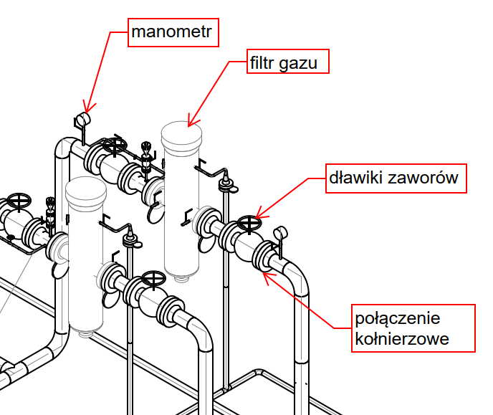
Figure A.1. Leaks in filtration systems

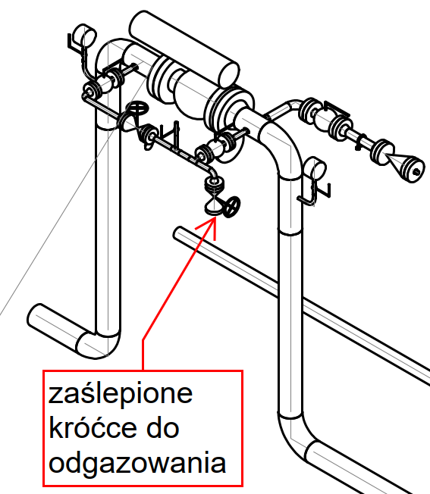

Figure A.2. Leakage location on the shut-off valve

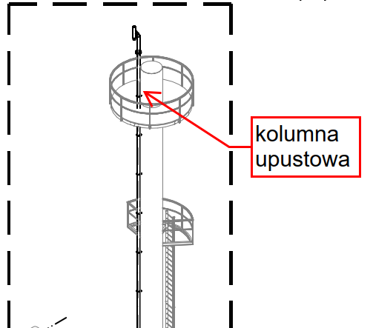

Figure A.3. Leaks on the bleed column

Appendix B
(informative)

Examples of leaks in gas distribution networks
This Annex provides schematic examples of leak locations in natural gas distribution networks within gas points and at gas connection ends. The main tap in front of the gas meter, fittings at the gas regulator, mono connector for the gas meter, valve on the side of the gas system, PE/Steel connection, flange valve were indicated as escape points.
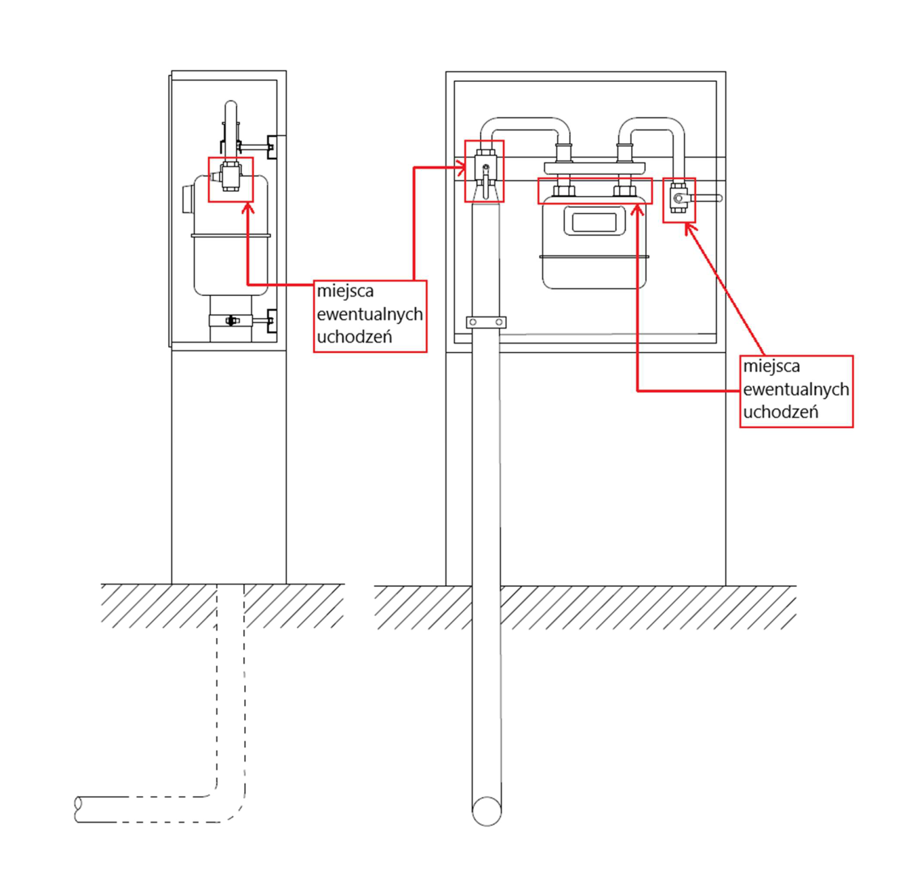
Figure B.1. Leaks at the gas point at low pressure
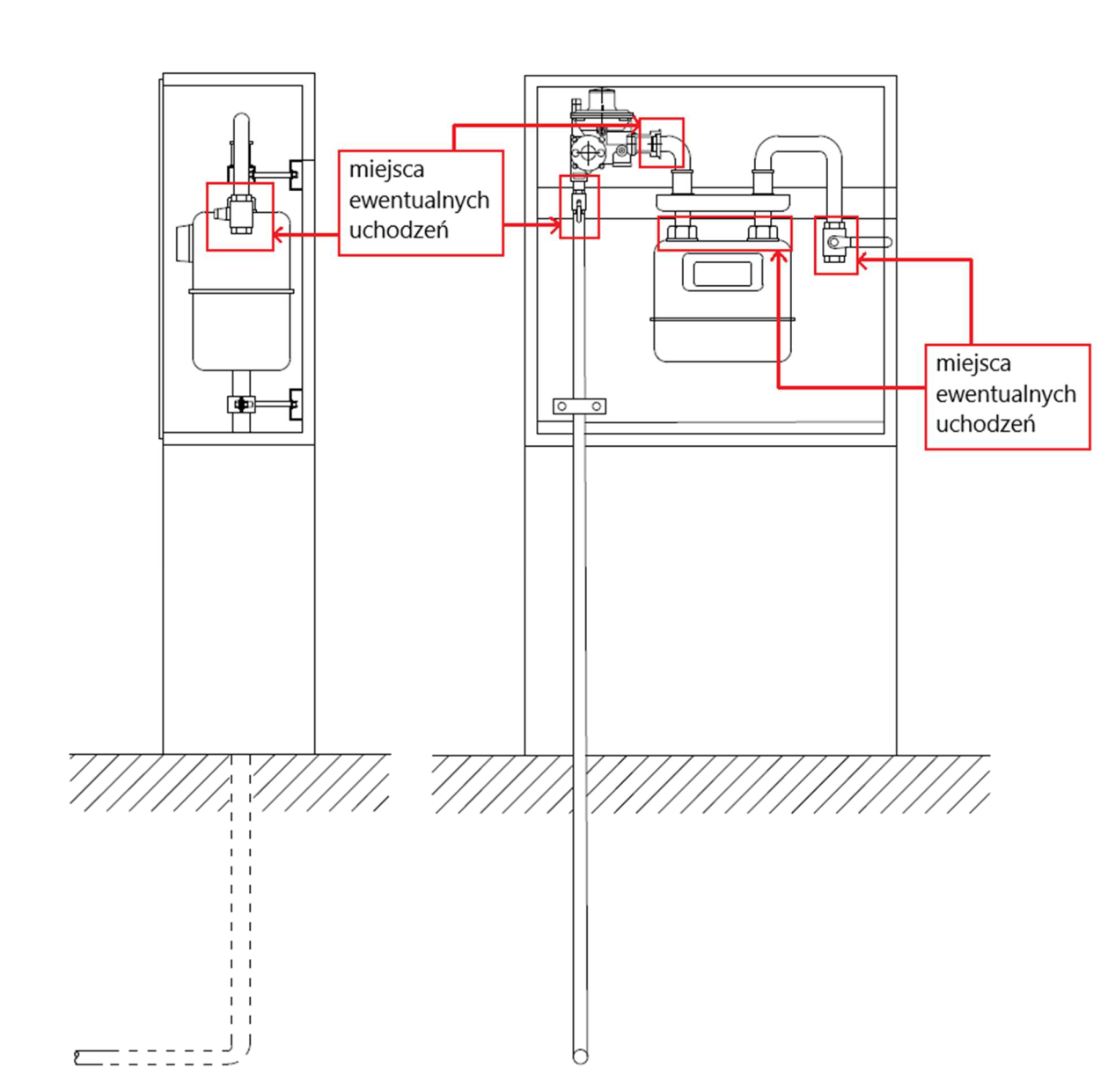

Figure B.2. Leaks at the gas point at medium pressure
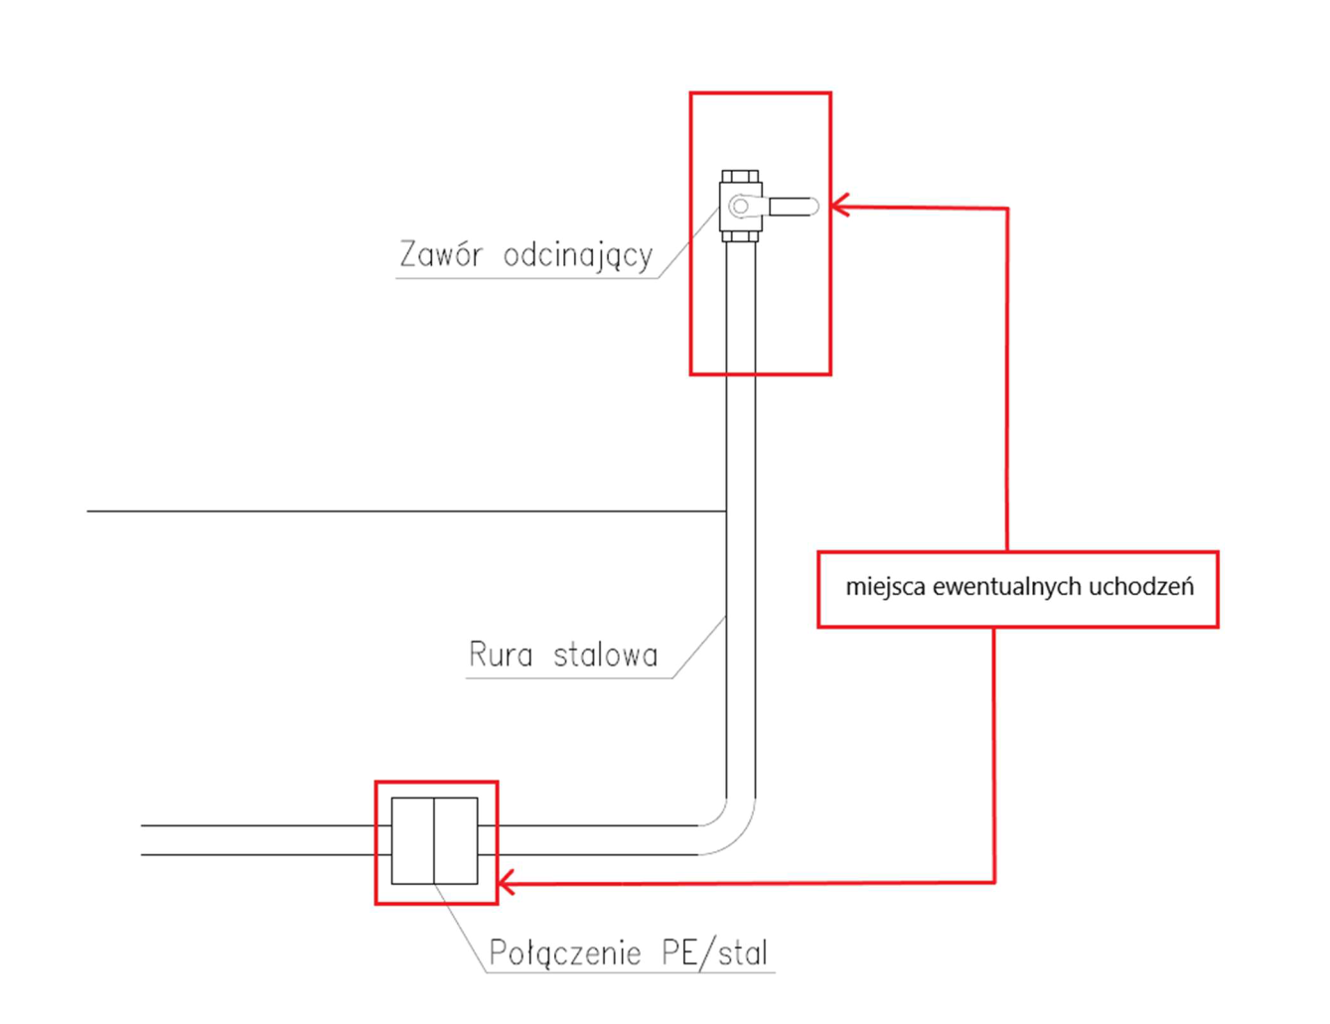
Figure B.3. Leaks at the end of the gas connection
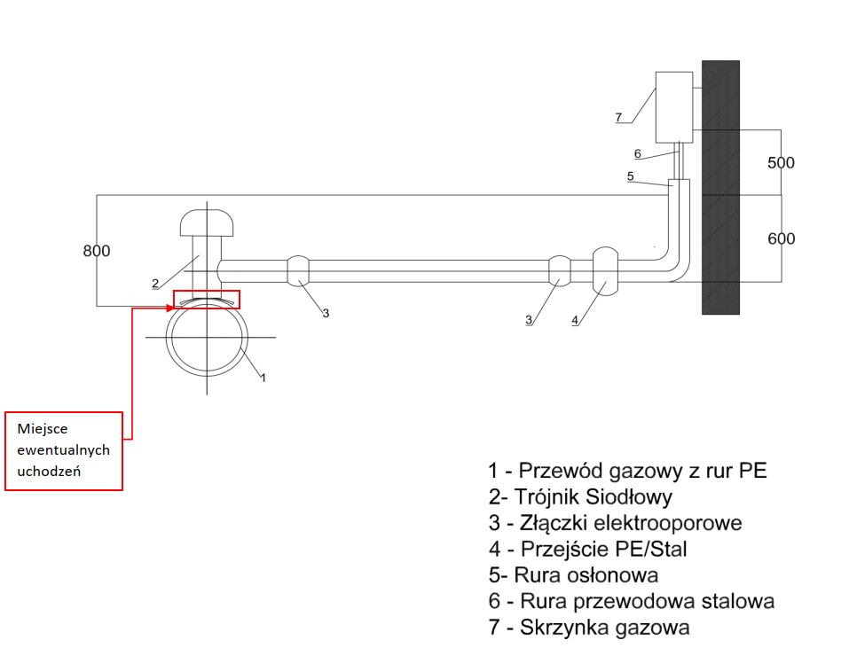

Figure B.4. Leaks at the end of the gas connection

Appendix C
(informative)

Overview of methods used for leak detection
This Annex characterises the methods that can be used to detect leaks that are sources of volatile methane emissions in the gas sector, indicating their possible applications, disadvantages, advantages and the equipment necessary to implement them.
Table C.1 — Foaming agent method
Scope | Detection, measurement possible but not recommended
Description of the method | Potential leaks are coated with an aqueous surfactant solution and then bubble formation (detection) and bubble size (measurement) are observed
Advantages | - low-cost,  - allows you to detect even small leaks,  - allows for immediate location of the leak,  - does not require any special equipment,
Disadvantages | - The effectiveness of leak detection largely depends on the experience and meticulousness of the staff,  - may only be applied to components that are easily accessible,  - high uncertainty for quantitative measurement (up to 500%), not recommended for use as a measurement method
Device | - foaming agent (surfactant solution) or  - spray leak detector

Table C.2 – Acoustic imaging
Scope | Detection, measurement also possible
Description of the method | The method is based on ultrasonic measurements, which are often the first indication of damage and gas leakage from the infrastructure. This method can be used in two variants.  Variant 1  A device whose surface consists of dozens of sensors listening to the sound field. When an ultrasonic wave hits a surface, sensors detect the ultrasound at different times. These differences are used to locate the sources of ultrasound and present them as an image. The device takes into account an unlimited number of simultaneous sources  Variant 2  Analysis of the noise profile in the pipeline, which is created with the use of acoustic sensors installed along the pipeline. Deviations from the profile obtained in this way are a signal of a gas leak
Advantages | - option 1: possibility of simultaneous detection and measurement of methane emissions,  - Option 2: Possibility to accurately indicate the location of leaks on linear objects
Disadvantages | - Option 1: Ambient noise sensitive method  - option 2 method dedicated only to gas pipelines,  - Multiple acoustic sensors need to be installed to monitor longer distances
Device | - Acoustic Sensors

Table C.3 — Passive optical method
Scope | Detection, measurement also possible
Description of the method | The method involves the use of an OGI (Optical Gas Imaging) camera with infrared sensors. This method uses the phenomenon of absorption of infrared (IR) radiation by methane molecules. As a result, the leak can be visualized in infrared light due to the weakening of the background radiation by methane particles in the air. This method can be successfully used to detect leaks in both above-ground and underground infrastructure.  When using OGI, an infrared camera operator scans the site of a potential leak, and the scanned area is viewed in real time, so that emissions can be detected. Some OGI cameras enable simultaneous detection of emissions and measurement of emission flux thanks to the use of cooperation with quantitative optical gas imaging (QOGI) systems
Advantages | - high speed and precision in detecting gas leaks  - possibility to carry out measurements during typical operation of the installation
Disadvantages | - Lack of resistance to weather conditions
Device | - OGI camera

Table C.4 — Active optical method
Scope | Detection
Description of the method | These methods use a diode or pulsed laser.  A pulsed laser LIDAR system for gas leak detection from gas pipelines uses the observation of the methane spectral line of light scattered by the air in the vicinity of the leak. To do this, a pulse of laser radiation is directed towards a gas pipeline or an element of infrastructure. Then, the radiation scattered in the direction from which the pulse originates is collected by the receiver and directed to the detector input, where the Ramman band with a wavelength characteristic of methane is extracted. The signal selected in this way then reaches the photodetector, which converts it into a digital form that allows it to be assessed whether there is a leak in a given place.  Another active optical method is based on the use of a much cheaper device based on a diode laser, which generates electromagnetic radiation with an adjustable wavelength.
Advantages | - can be used both as handheld devices and devices used to monitor networks from cars or from the air
Disadvantages | - high purchase and operating costs  - the need for professional staff  - frequent generation of false alarms
Device | - pulsed laser, or  - diode laser

Table C.5 – Method based on air composition analysis
Scope | Detection
Description of the method | These methods take advantage of the fact that when a leak occurs in the vicinity of the leaking component, the methane concentration increases. These methods use devices that detect the presence of hydrocarbons (methane) in the air in concentrations not exceeding a few ppm. Depending on the solution used, either stationary devices deployed on the network or mobile devices are used.
Advantages | - can be used even in the case of offshore gas pipelines,  - high sensitivity and selectivity of the method, which allows for the detection of even small leaks and causes this method to give a relatively small number of false alarms
Disadvantages | - low effectiveness of the use of these methods, depending to a large extent on the frequency of inspections,  - the need for professional staff
Device | - methane detectors equipped with various types of sensors

Table C.6 — Method using sensors in the form of electrical wires
Scope | Detection
Description of the method | A method for detecting leaks on linear elements of gas networks, along which sensors in the form of electrical wires are laid.  Variant 1  An electrical cable is made of a material that reacts when it comes into contact with hydrocarbons. As a result of the reactions, some properties of electrical wires change, e.g. strength, capacitance or impedance, which are monitored in order to detect leaks  Variant 2  Hydrocarbons act on the insulating sheath of the cable. As a result of this impact, swelling or degradation of the insulating coating may occur. In this case, if the electrical wires are properly laid, a short circuit will occur at the point of the leak, which generates an alarm signal
Advantages | - relatively quick reaction of the measuring system to the occurrence of leaks  - high sensitivity of the method  - possibility of locating leaks with an accuracy of up to 20 m
Disadvantages | - can only be used for the linear part of the gas network  - difficulties in applying this method in the case of existing gas pipelines, consisting in the need to expose the entire monitored section of the gas pipeline  - high costs
Device | - appropriate wiring laid along the gas pipeline

Table C.7 — Method using sensors in the form of optical fibre cables
Scope | Detection
Description of the method | The use of optical fibers for continuous monitoring of gas leaks is based on the physical phenomena that occur at the point of the leak. One of them is the change in temperature that occurs at the time of expansion of the adiabatic gas. A local drop in temperature that occurs at the site of the leak causes changes in the temperature profile. In order to detect such changes, the optical fiber is placed along the gas pipeline, and then the temperature profile along the fiber is examined using laser pulses.
Advantages | - high accuracy in locating the location of leaks
Disadvantages | - can only be used for the linear part of the gas network  - difficulties in applying this method in the case of existing gas pipelines, consisting in the need to expose the entire monitored section of the gas pipeline  - high costs
Device | - optical fibre laid along the gas pipeline

Appendix D
(informative)

Overview of methods used to measure methane emissions
This Annex characterizes the methods that can be used for the measurement of fugitive methane emissions in the gas sector, indicating their advantages, disadvantages and the equipment necessary to implement them.
Table D.1 – Analysis of pressure drop or fluctuation of flow
Scope | Measurement
Description of the method | The method can be used as a quantitative technique to measure gas leaks over a known pipeline length for isolated parts of a distribution and transmission network. The pressure inside the pipeline is measured over a specified period of time, and the leakage is calculated based on the pressure drop and the known (estimated) volume of the pipeline section. The sensitivity of the pressure monitoring method depends on the location of the leak. The closer the leak is to the inlet or outlet, the smaller the change in pressure (it may not occur at all).
Advantages | - line  - No telemetry required
Disadvantages | - high uncertainty due to changes in gas temperature during measurement  - inability to locate leaks  - can only be used under steady-state conditions  - The section for which the measurement is carried out must be isolated from the rest of the network  - The larger the volume of the pipeline and the higher the flow rate, the more inaccurate this technique is  - no possibility to measure at high pressures  - Can be used for medium and low pressure distribution networks
Device | - Pressure Sensors  - Meters

Table D.2 — Mass balance methods
Scope | Measurement
Description of the method | These methods are based on the principle of conservation of mass. In a steady state, the mass flow flowing into a sealed pipeline is equal to the mass flow flowing out of it. An uneven mass balance may indicate a leak. First, gas flow measurements are taken to determine its dependence on pressure. Next, it is necessary to estimate or measure the gas consumption by end users, the next step is to estimate the amount of methane emissions from the leaking section of the gas pipeline (this is the difference between the total value of the gas volume stream – determined interpolationally and the gas consumption by consumers).
Advantages | - The simple principle of the method
Disadvantages | - difficult to apply in real conditions due to irregular gas collection,  - The uncertainty of the measurement of the equipment translates to a large extent into the uncertainty of the
Device | - Pressure Sensors  - Meters

Table D.3 — Tracer gas methods
Scope | Measurement
Description of the method | The method involves introducing a chemical tracer in gas form into the gas pipeline near the leak (most often at gas stations). The tracer should be a gaseous substance that is not hazardous and highly stable. The methane concentration and the release tag concentration are then measured and the methane emission is calculated from the corresponding equation.  $$E_{CH4}=Q_{znacznika}∙\frac{C_{CH4}-C_{CH4, tło}}{C_{znacznika}-C_{znacznika ,tło}}$$  where:  ECH4 – methane emission [g/s]  Qtaga – the rate of release of the tracer into the gas network [g/s]  CCH4 – measured methane concentration [g/m3]  CCH4,background - methane concentration measured as background [g/m3]  Ctracer – measured tracer concentration [g/m3]  Ctag, background – tracer concentration measured as background [g/m3]  In this method, Fourier transform spectroscopes or CRDS spectrosscopes are used to determine the concentration of the marker.
Advantages
Disadvantages | - limited use possibilities (unbranched sections, close to gas stations where the marker is introduced)  - Some of the tracers used are toxic or radioactive
Device | - tags, e.g. sulphur hexaphłuoide, ethene, radioactive tags  - devices for measuring the concentration of methane and the tracer in the air

Table D.4 — Methods using gas-tight bags
Scope | Measurement
Description of the method | Wrap the leak area with a gas-tight material and then direct the gas flowing out of the leak to the flow meter. In order to increase the accuracy of the measurement, inert gas can be supplied to the flowmeter at a constant speed, in which case it is necessary to measure the methane concentration in the mixture passing through the flow meter. The amount of emissions is calculated from the equation:  $$E_{CH4}=F_{gazu}∙C_{CH4}$$  where:  ECH4 – methane emission [m3/h]  Fgas – gas flow rate measured with a flow meter [m3/h]  CCH4 – measured methane concentration [%]
Advantages | - High Accuracy
Disadvantages | - Labour intensity  - the need to obtain the right pressure and flow to enable the measurement,  - no possibility of testing underground elements
Device | - gas-tight material  - Flow meter  - inert gas (optional)  - methane measuring devices (optional)

Table D.5 — Methods of measurement with air flow
Scope | Measurement
Description of the method | This method is based on the fact that the forced air flow at the leak point directs the escaping gas to the measuring system, where the gas flow velocity is measured and the methane concentration in the flowing gas is measured. In addition, the methane concentration in the atmospheric air, which is the background of these measurements, is measured.
Advantages | - High Accuracy  - can be used for a variety of components  - Wide measuring range  - Relatively short response time
Disadvantages | - necessary selection of measuring accessories and air flow velocity, so that all methane escaping from the leaking element is directed to the measuring system,  - low availability of devices on the market that implement this method automatically,  - Non-commercial systems for measurements using this method are complicated to operate
Device | - dedicated devices for measuring emissions using the airflow method

Appendix E
(informative)

Tabulated Gas Outflow Rates from Low and Medium Pressure Pipelines through a Well with a Known Surface for Gas Pipelines
In order to simplify the calculation of methane emissions caused by low or medium pressure pipeline failures involving gas outflow through a gap (borehole) of known size, the corresponding tabulated gas outflow quantities are provided in this Annex.
Table E.1 – Volumes of natural gas outflow to the atmosphere from the low-pressure pipeline
Lp. | Equivalent hole diameter [mm] | Gas outflow [m3/h] given gas overpressure in gas pipeline (pr)
Lp. | Equivalent hole diameter [mm] | 2.0 kPa | 2.5 kPa | 5.0 kPa | 10.0 kPa
1. | 5 | 3,2 | 3,5 | 5,0 | 7,1
2. | 10 | 13 | 14 | 20 | 28
3. | 15 | 28 | 32 | 45 | 64
4. | 20 | 51 | 57 | 80 | 113
5. | 25 | 79 | 88 | 125 | 177
6. | 30 | 114 | 127 | 180 | 254
7. | 32 | 129 | 145 | 205 | 289
8. | 35 | 155 | 173 | 245 | 346
9. | 40 | 202 | 226 | 320 | 452
10. | 45 | 256 | 286 | 405 | 572
11. | 50 | 316 | 353 | 500 | 707
13. | 60 | 455 | 509 | 719 | 1 017
14. | 70 | 619 | 692 | 979 | 1 385
15. | 80 | 809 | 904 | 1 279 | 1 809
16. | 90 | 1 024 | 1 145 | 1 619 | 2 289
17. | 100 | 1 264 | 1 413 | 1 998 | 2 826
18. | 150 | 2 844 | 3 179 | 4 496 | 6 359
19. | 200 | 5 055 | 5 652 | 7 993 | 11 304

Table E.2 — Volumes of natural gas discharge to the atmosphere from the medium pressure pipeline
Lp. | Equivalent hole diameter [mm] | Gas outflow [m3/h] given gas overpressure in gas pipeline (pr)
Lp. | Equivalent hole diameter [mm] | 200 kPa | 250 kPa | 300 kPa | 350 kPa | 400 kPa
1. | 5 | 45 | 53 | 60 | 68 | 75
2. | 10 | 181 | 211 | 241 | 271 | 301
3. | 15 | 406 | 474 | 542 | 609 | 677
4. | 20 | 722 | 843 | 963 | 1 083 | 1 204
5. | 25 | 1 129 | 1 317 | 1 505 | 1 693 | 1 881
6. | 30 | 1 625 | 1 896 | 2 167 | 2 438 | 2 709
7. | 32 | 1 849 | 2 157 | 2 466 | 2 774 | 3 082
8. | 35 | 2 212 | 2 581 | 2 949 | 3 318 | 3 687
9. | 40 | 2 889 | 3 371 | 3 852 | 4 334 | 4 816
10. | 45 | 3 657 | 4 266 | 4 876 | 5 485 | 6 095
11. | 50 | 4 515 | 5 267 | 6 019 | 6 772 | 7 524
13. | 60 | 6 501 | 7 584 | 8 668 | 9 751 | 10 835
14. | 70 | 8 848 | 10 323 | 11 798 | 13 273 | 14 747
15. | 80 | 11 557 | 13 483 | 15 410 | 17 336 | 19 262
16. | 90 | 14 627 | 17 065 | 19 503 | 21 941 | 24 378
17. | 100 | 18 058 | 21 068 | 24 078 | 27 087 | 30 097
18. | 150 | 40 631 | 47 403 | 54 174 | 60 946 | 67 718
19. | 200 | 72 233 | 84 271 | 96 310 | 108 349 | 120 388

Appendix F
(informative)

Geometrical volumes of 1 km long gas pipelines
In order to simplify the calculations of methane emissions presented in Chapter 6, which use the geometric volume of the gas pipeline, the geometric volumes of 1 km long gas pipelines made of different materials and diameters are given in this Annex.
Table F.1 – Geometric volume of the 1 km long gas pipeline
Steel gas pipelines with a diameter in [mm] | 20 | 25 | 32 | 40 | 50 | 65 | 80 | 100 | 125 | 150 | 200 | 250 | 300 | 350 | 400 | 450 | 500 | 700 | 1000
Geometric volume in [m3] | 0,31 | 0,49 | 0,80 | 1,26 | 1,96 | 3,32 | 5,02 | 7,85 | 12,27 | 17,66 | 31,40 | 49,06 | 70,65 | 96,16 | 125,60 | 158,96 | 196,25 | 384,65 | 785,00
SDR 11 polyethylene gas pipelines with a diameter in [mm] | 20 | 25 | 32 | 40 | 50 | 63 | 75 | 90 | 110 | 125 | 160 | 180 | 200 | 225 | 250 | 315 | 355 | 400 | 450
Geometric volume in [m3] | 0,15 | 0,28 | 0,53 | 0,83 | 1,31 | 2,07 | 2,96 | 4,25 | 6,36 | 8,2 | 13,43 | 17,01 | 21,01 | 26,58 | 32,86 | 52,17 | 66,20 | 84,14 | 106,42
SDR 17 polyethylene gas pipelines with a diameter in [mm] | 20 | 25 | 32 | 40 | 50 | 63 | 75 | 90 | 110 | 125 | 160 | 180 | 200 | 225 | 250 | 315 | 355 | 400 | 450
Geometric volume in [m3] | 0,19 | 0,33 | 0,59 | 0,97 | 1,52 | 2,41 | 3,42 | 4,92 | 7,36 | 9,53 | 15,61 | 19,75 | 24,37 | 30,84 | 38,13 | 60,49 | 76,81 | 97,60 | 123,47
SDR 17.6 polyethylene gas pipelines with a diameter in [mm] | 20 | 25 | 32 | 40 | 50 | 63 | 75 | 90 | 110 | 125 | 160 | 180 | 200 | 225 | 250 | 315 | 355 | 400 | 450
Geometric volume in [m3] | 0,19 | 0,33 | 0,59 | 0,98 | 1,53 | 2,44 | 3,46 | 4,97 | 7,45 | 9,64 | 15,78 | 19,95 | 24,65 | 31,21 | 38,55 | 61,19 | 77,69 | 98,60 | 124,85
SDR 25 polyamide gas pipelines with a diameter in [mm] | 12 | 18 | 23 | 32 | 40 | 50 | 63 | 75 | 110 | - | - | - | - | - | - | - | - | - | -
Geometric volume in [m3] | 0,08 | 0,20 | 0,35 | 0,68 | 1,06 | 1,66 | 2,62 | 3,74 | 8,01 | - | - | - | - | - | - | - | - | - | -

Appendix G
(informative)

Emission source categories for OGMP levels for the transmission and distribution of natural gas
This Annex presents the reporting levels for methane emissions based on the OGMP form developed by Marcogaz and dedicated to the transmission and distribution of natural gas.
When assigning categories of emission sources to individual reporting levels, the colour scheme presented in Table G.1 was used.
Table G.1 – Legend
Level 1 | Global level - a single methane emission quantity determined for all operations or facilities of a given type
Level 2 | Emissions reported by simplified emission sources
Level 3 | Emissions determined by emission source using emission factors for the entire group of sources. (connections, valves, flares, turbines, gas engines)
Level 4 | Emission determined for specified emission sources using EF emission factors and AF activity factors  On-site measurements, simulation tools, and engineering calculations should serve as a basis for determining EF coefficients
Level 5 | Level 4 emissions, measurements taken for a statistically representative population

Table G.2 – Assignment of emission source categories in gas transmission to individual OGMP levels
Level 1 | Level 2 | Level 3 | Level 4 & 5
Linear part | Gas vents | Emissions related to operations | Consumable Discount
Linear part | Gas vents | Emissions related to operations | Bleed – gassing/degassing
Linear part | Gas vents | Incidents and breakdowns
Linear part | Incomplete combustion | Gas flares
Compressor stations (each facility separately) | Volatile emissions | Connections (flanges, seals, connectors)
Compressor stations (each facility separately) | Volatile emissions | Valves & Control Valves
Compressor stations (each facility separately) | Volatile emissions | Bleed valves
Compressor stations (each facility separately) | Volatile emissions | Open end gas lines for blowing out
Compressor stations (each facility separately) | Volatile emissions | Open End Gas Lines
Compressor stations (each facility separately) | Volatile emissions | Other sources of volatile emissions
Compressor stations (each facility separately) | Gas vents | Maintenance discounts
Compressor stations (each facility separately) | Gas vents | Vents from pneumatic devices | Pneumatic valves
Compressor stations (each facility separately) | Gas vents | Vents from pneumatic devices | Gas Quality Measuring Equipment
Compressor stations (each facility separately) | Gas vents | Vents from pneumatic devices | Compressor Unit Seals
Compressor stations (each facility separately) | Gas vents | Start-stop discounts | Degassing
Compressor stations (each facility separately) | Gas vents | Start-stop discounts | Carbonation
Compressor stations (each facility separately) | Gas vents | Incidents and breakdowns
Compressor stations (each facility separately) | Incomplete combustion | Gas flares
Compressor stations (each facility separately) | Incomplete combustion | Gas turbines
Compressor stations (each facility separately) | Incomplete combustion | Gas Engines
Compressor stations (each facility separately) | Incomplete combustion | Other sources (e.g. gas boilers)
Gas stations (total) | Volatile emissions | Connections (flanges, seals, connectors)
Gas stations (total) | Volatile emissions | Valves & Control Valves
Gas stations (total) | Volatile emissions | Bleed valves
Gas stations (total) | Volatile emissions | Open end gas lines for blowing out
Gas stations (total) | Volatile emissions | Open End Gas Lines
Gas stations (total) | Volatile emissions | Other sources of volatile emissions
Gas stations (total) | Maintenance discounts | Maintenance discounts
Gas stations (total) | Maintenance discounts | Incidents and breakdowns
Gas stations (total) | Maintenance discounts | Vents from pneumatic devices | Pneumatic valves
Gas stations (total) | Maintenance discounts | Vents from pneumatic devices | Gas Quality Measuring Equipment
Gas stations (total) | Incomplete combustion | Gas flares
Gas stations (total) | Incomplete combustion | Other combustion sources (e.g. boiler rooms)
Table G.3 – Assignment of emission source categories in gas distribution to individual OGMP levels
Level 1 | Level 2 | Level 3 | Level 4 & 5
Linear part (gas pipelines) | Volatile emissions | Permeation (PE pipes) | Three pressure ranges
Linear part (gas pipelines) | Volatile emissions | Permeation (PVC pipes) | Two pressure ranges
Linear part (gas pipelines) | Volatile emissions | Permeation (PA pipes) | Three pressure ranges
Linear part (gas pipelines) | Volatile emissions | Permeation (non-metallic pipes) | Three pressure ranges
Linear part (gas pipelines) | Volatile emissions | Leaks detected during routine leak checks | Three pressure ranges
Linear part (gas pipelines) | Gas vents | Maintenance discounts | Carbonation
Linear part (gas pipelines) | Gas vents | Maintenance discounts | Degassing
Linear part (gas pipelines) | Gas vents | Incidents and breakdowns | Incidents caused by third parties divided into three pressure ranges
Linear part (gas pipelines) | Gas vents | Incidents and breakdowns | Failures (e.g. corrosion) divided into three pressure ranges
Gas connections | Fugitive emissions | Permeation | Three pressure ranges
Gas connections | Fugitive emissions | Leaks detected during routine leak checks | Three pressure ranges
Gas connections | Gas vents | Maintenance discounts | Carbonation
Gas connections | Gas vents | Maintenance discounts | Degassing
Gas connections | Gas vents | Incidents and breakdowns | Incidents caused by third parties divided into three pressure ranges
Gas connections | Gas vents | Incidents and breakdowns | Failures (e.g. corrosion) divided into three pressure ranges
Reduce, measuring or power supply stations; valve and bleed units; | Fugitive emissions | Three inlet pressure ranges
 | Gas vents | Operating drains (valves/filter cleaning)
 | Gas vents | Vents from pneumatic devices
 | Gas vents | Incidents and breakdowns
LNG stations | Fugitive emissions
LNG stations | Gas vents | Maintenance discounts
LNG stations | Gas vents | Incidents and breakdowns
Meters | Gas vents during replacement and dismantling | Domestic and small commercial
Meters | Gas vents during replacement and dismantling | Industrial

Appendix H
(informative)

Bibliography
- Law of 27 April 2001 Environmental law (i.e. Journal of Laws of 2019, item 1219)
- Act of 17 July 2009 on the system for managing emissions of greenhouse gases and other substances (i.e. Journal of Laws of 2020, item 1077)
- KOBiZE website https://krajowabaza.kobize.pl/
- Marcogaz "Assessment of methane emissions for gas Transmission and Distribution system operators"
- U.S. Environmental Protection Agency (US EPA) & Gas Research Institute (GRI) "Methane emisssions from the natural gas industry"
- Standard PN-EN 15446:2008 Uncontrolled and diffuse emissions in the industrial sector – measurement of vapour emissions from leaking installations and pipes
- Communication from the Commission to the European Parliament, the Council, the European Economic and Social Committee and the Committee of the Regions on an EU strategy to reduce methane emissions of 14.10.2020
- 2006 IPCC Guidelines for National Greenhouse Gas Inventories
- Mineral Methane Initiative OGMP 2.0 Framework
- Guide for filling out the methane emissions reporting template
- Transmission Network Operation System (SESP) – Procedure P.02.O.05 Records of own consumption and gas losses of the Gas Transmission Operator GAZ-SYSTEM S.A.
- Comparison of results obtained with diffrent approaches to natural gas emissions measuremnts project No. 2.73 -The European Gas Research Group (GERG)
- G. Demusiak and team "Assessment of natural gas emissions and verification of emission factors from selected gas compressor stations in the transmission system
- GAZ-SYSTEM S.A. – Stage III, part I", unpublished, Warsaw, 20.11.2012
- Verification and application of the correlation method for estimating methane emissions in the gas industry on the basis of laboratory tests. Grzegorz Demusiak, Mariusz Koc Oil and Gas Institute – National Research Institute - Gas, Water, Sanitary Technology December 2016
- "An Eye on Methane International Methane Emissions Observatory 2021 Report" – United Nations Environment Programme
- "Measurements of methane emissions and update of emission factors for metering stations located in the transmission system" INiG – National Research Institute, Department of Environmental Protection. Krakow 2021
- "Investigation of the impact of variability of operating conditions of reciprocating compressors on natural gas emissions from gas compressor stations on the example of selected emission sources at the facilities operated by GAZ-SYSTEM S.A. – Stage I and II". INiG – National Research Institute. Warsaw 2016
- "Assessment of emissions and the possibility of reducing methane emissions from valve and bleed units and gas pipelines with expansion joints in the transmission system of GAZ-SYSTEM S.A. – Stage II" INiG – National Research Institute. 2015
- Survey methane emissions for gas distribution in Europe WG-ME-17-25 Marcogaz, February 2018
- OGCI Reporting Framework October 2020– V.3.32019 Refinement to the 2006 IPCC Guidelines for National Greenhouse Gas Inventories

